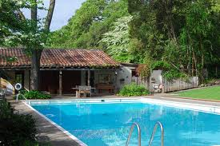

Westerbeke Yoga Retreat

with Elise Browning Miller and Marla Apt
Friday – Sunday, October 21-23, 2022

The Westerbeke Ranch, located outside Sonoma in the heart of the wine country, only 60 miles from San Francisco, is a charming place to practice yoga. Facilities include comfortable redwood cabins, sun decks, Jacuzzi, and a large swimming pool. The food is vegetarian California country cuisine – and you will find it a special treat. There is a fish option on Saturday.

The retreat begins at 4:00 PM on Friday and ends after lunch on Sunday. There are separate asana classes for beginning and intermediate students. Early morning meditation will also be offered and there will be plenty of free time to hike, bike or simply relax in the beautiful surroundings. Massage might be available for an additional fee – awaiting further notice.

Friday-Sunday weekend retreat includes: accommodations for two nights, a yoga class late Friday afternoon, two classes Saturday and one morning class Sunday. All meals are provided from dinner on Friday through lunch on Sunday. At this time a majority of available rooms are double occupancy due to Covid 19 restrictions. Price is $895 paid in full OR $150 deposit plus $770 balance (total $920).

Please register early.
Cancellation received on or before August 1, 2022 will receive a full refund LESS $40.00 processing fee.

For More Information/Registration: Elise Miller, PO Box 22346, Carmel, CA 93922
/ www.ebmyoga.com / email: info@ebmyoga.com

Elise Browning Miller & Marla Apt at Westerbeke Ranch October 21-23, 2022

Friday - Sunday (October 21-23)
Rates per Person
❑ Pay in Full | ❑ Pay with Deposit
Couples/Double Occupancy room $895   Double bed or  Two single beds | $150 deposit + balance due $770 by Sept 1   Double bed or  Two single beds

Total Amount Enclosed $_____________ Number of Reservations_____________

Name_________________________________________Phone___________________________________
Address_______________________________________________________________________________
City___________________________________________ State_______________Zip__________________
Email________________________________________
Names of roommates in your party (relationship to them – we need this information for bed arrangements): ___________________________________________________________
Check_______ Credit Card # _______________________________________Expiration Date___________
- Please Note: Your Credit Card charge will be made to Shanti Productions.
-----------------------------------------------------------------------------------------------------------------------------------------------------------
To reserve a workshop space, send form along with fee to Elise Miller, Po Box 22346, Carmel, CA 93922.
For more information, e-mail: info@ebmyoga.com

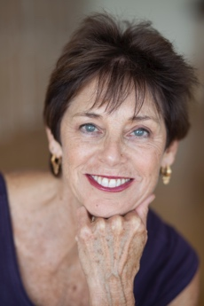
Elise Browning Miller, M.A. in Therapeutic Recreation - is a founding director of the California Yoga Center in Mountain View, CA. She is a senior level Certified Iyengar Yoga Teacher, who has taught yoga since 1976. Elise teaches special workshops on scoliosis, leads yoga retreats internationally and sees students privately for scoliosis, other back problems, and sports related injuries. Elise recently published her comprehensive book Yoga for Scoliosis – A Path for Students & Teachers. This along with her book, Yoga: Anytime, Anywhere, her Yoga for Scoliosis DVD, Yoga for Back Care and Yoga for Scoliosis booklet and her Intermediate Yoga in Fiji DVD are available for sale at the retreat. Her joyous personality and ease of communication endear her to students with a teaching style that is down-to-earth, precise and nurturing. Visit Elise's website: www.ebmyoga.com or www.yogaforscoliosis.com.

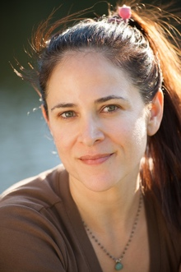
Marla Apt is a Senior level Certified Iyengar Yoga teacher with over 25 years of experience teaching yoga and studying with BKS Iyengar and the Iyengar family. Highlighted by Yoga Journal Magazine as one of twenty-one yoga teachers helping to “shape the future of yoga,” Marla has been teaching Iyengar Yoga in Los Angeles, nationally and internationally for over 25 years. Since visiting India for the first time to conduct research for a degree in Buddhist philosophy, Marla has returned annually to study yoga with B.K.S. Iyengar and his children, Geeta and Prashant. She helped design and assisted with medical research studies at UCLA on yoga as a treatment for depression, anxiety, and IBS. In addition, Marla has created the first yoga therapy content to be incorporated into the curriculum of the David Geffen School of Medicine at UCLA. Visit Marla’s website: www.yoganga.com.

