YOGA FOR SCOLIOSIS & BACK CARE
in Mexico with Elise Browning Miller
November 12 – 19, 2022

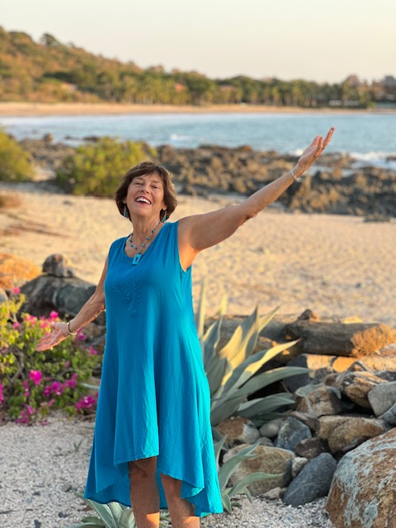

Teachers and Students are welcome to join Elise for a Yoga for ScOLIOSIS & Back Care Retreat.
This retreat is open to anyone with scoliosis or back issues who is looking to learn ways to relieve back problems with yoga, and deepen their practice in a magical, tranquil environment.

The retreat will be located in the idyllic retreat site of Yoga del Pacifico on Manzanilla Bay, one of the most beautiful and tranquil beaches in Troncones, Mexico located 20 miles from the fishing village of Zihuatanejo. You will be staying at Merece Tus Suenos “Deserve your Dreams” merecetussuenos.com and Casa Marea "House of the Tide” casamarea.com, just minutes away from Yoga del Pacifico. Brunch and dinner are included with delicious seafood and vegetarian entrees for dinner from top restaurants nearby. There will be two yoga sessions a day with plenty of time in between for relaxing in your favorite style. Hanging out in a hammock, swimming, surfing, snorkeling, hiking, horseback riding, bird watching, massage, pedicures and manicures are all available options.

This retreat will address different back issues including scoliosis and general asymmetry of the body, poor posture, lower back pain and chronic neck and shoulder pain. Elise will address how to adapt yoga poses therapeutically for these conditions with a focus of alignment, lengthening and strengthening the back and breath awareness. The retreat is appropriate for those dealing with their own back-related issues as well as yoga teachers who wish to assist their students to address their conditions.

Double occupancy $1995.00
Single Occupancy additional fee of $500
Deposit: $995 for doubles, $995 + $550 for single

Price includes yoga classes, two daily meals, double or single accommodations, transportation to and from Zihuatanejo/Ixtapa airport to the retreat site.

Please fill out the registration form below along with deposit and return to Elise Miller PO Box 22346, Carmel, CA 93922. For any questions, email ebm@yogaforscoliosis.com.

Please arrange to arrive by 4pm on Saturday, November 12 for dinner and an orientation. The retreat will end after class and breakfast on Saturday, November 19.

Yoga for Scoliosis & Back Care, Mexico - November 12 - 19, 2022

A non-refundable deposit of $995 for doubles, $995 + $550 for single is due by May 1st, 2022 per person to reserve your space. Balance of payment is due September 1st, 2022. Please fill out the registration form below and return to Elise Miller.
Registration form:
NAME:__________________________________________________________________________________
ADDRESS:________________________________________________________________________________

CITY:________________________________ STATE:_____________________________ ZIP:______________

PHONE:_____________________ EMAIL:_______________________________________________________

TOTAL # OF PEOPLE IN YOUR PARTY: ___________

FEE PER PERSON IN FULL: $1995______ DEPOSIT PER PERSON: $995 for double______ $1545 for single______

TOTAL ENCLOSED $:__________

CHECK_____CREDIT CARD (additional 3.3% fee)___________________________________EXP DATE__________CVV_______

Please make checks payable to: Elise Miller
Mail payment and registration form to: PO Box 22346, Carmel, CA 93922

Cancellations: Before September 1, 2022, a $50 cancellation fee will be charged. After September 1, cancellations will only be refunded – minus $50 fee, if your space is filled from the waiting list.

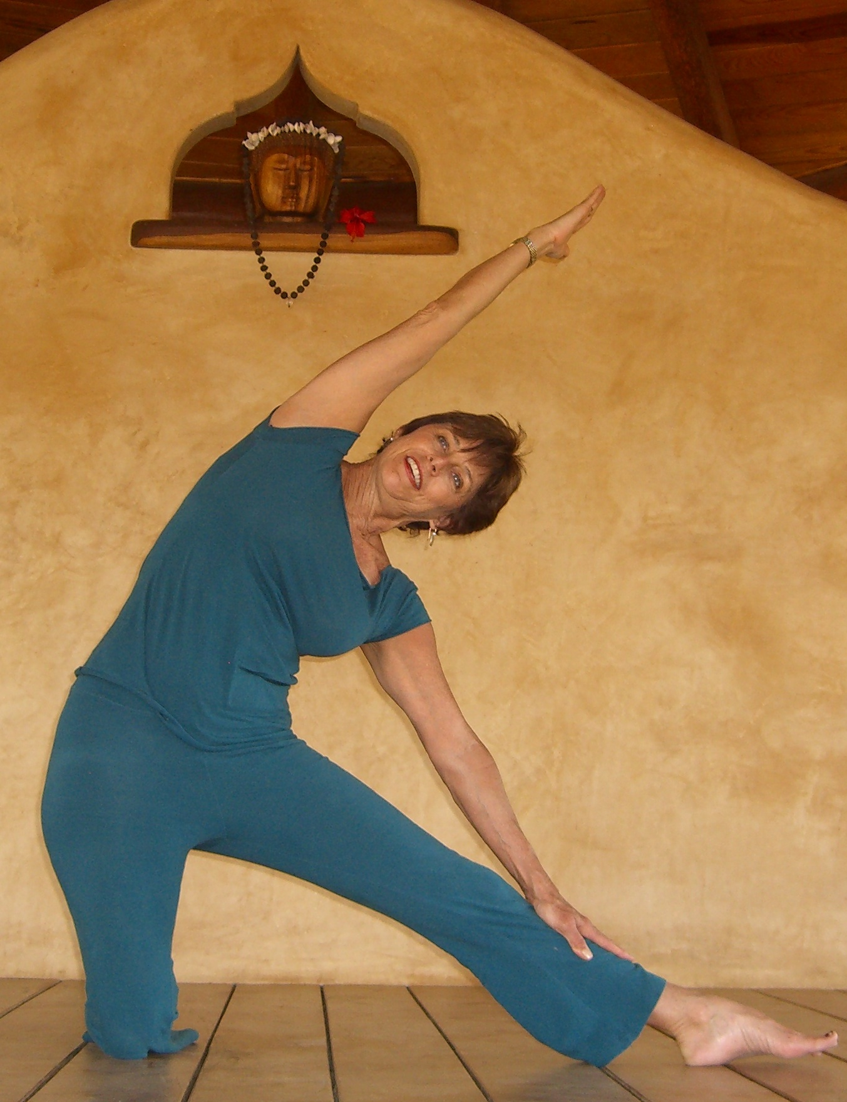
Elise Browning Miller, M.A. in Therapeutic Recreation - is a founding director of the California Yoga Center in Mountain View, CA. She is a senior level Certified Iyengar Yoga Teacher, who has taught yoga since 1976. Elise teaches special workshops on scoliosis, leads yoga retreats internationally and sees students privately for scoliosis, other back problems, and sports related injuries. Elise recently published her comprehensive book Yoga for Scoliosis – A Path for Students & Teachers. This along with her book, Yoga: Anytime, Anywhere, her Yoga for Scoliosis DVD, Yoga for Back Care and Yoga for Scoliosis booklet and her Intermediate Yoga in Fiji DVD are available for sale at the retreat. Her joyous personality and ease of communication endear her to students with a teaching style that is down-to-earth, precise and nurturing. Visit Elise's website: www.ebmyoga.com or www.yogaforscoliosis.com.

